**Neural Networks  
Task 3 – Dataset (Penguins)**

**Team_ID: CS_H5**

|  |  |  |
| --- | --- | --- |
| **Member name** | **Department** | **ID** |
| 1. عصام الدين شريف جاب الله حسن | CS | 20191700387 |
| 1. حسن وليد حسن السيد | CS | 20191700215 |
| 1. عبد الله رمضان السيد إبراهيم | CS | 20191700353 |
| 1. عمرو محمود زكريا جاد إبراهيم | CS | 20191700429 |
| 1. عمر هاني عبد الفتاح سيد أحمد غراب | CS | 20191700420 |

**Sigmoid Activation Function:**

|  |  |  |  |  |  |  |  |
| --- | --- | --- | --- | --- | --- | --- | --- |
| Train Accuracy | Test Accuracy | Bias | Epochs | Learning Rate | # Neurons | # Layers |  |
| S | 95% | Yes | 5000 | 0.01 | 5 | 1 | 1) |
| %97.77 | %85 | Yes | 2000 | 0.04 | 4,6,8 | 3 | 2) |
| 92.22% | %86.66 | No | 3000 | 0.05 | 3,2 | 2 | 3) |
| %96.66 | 100% | No | 3000 | 0.08 | 3,4,6,5 | 4 | 4) |

2

1

3

4

**Tanh Activation Function:**

|  |  |  |  |  |  |  |  |
| --- | --- | --- | --- | --- | --- | --- | --- |
| Train Accuracy | Test Accuracy | Bias | Epochs | Learning Rate | # Neurons | # Layers |  |
| 97.7% | 90% | Yes | 3000 | 0.001 | 3,4 | 2 | 1) |
| %93.33 | %91.66 | Yes | 2000 | 0.001 | 8 | 1 | 2) |
| 70.0% | %75.0 | No | 6000 | 0.0001 | 8,6,3 | 3 | 3) |
| 100% | 96.67% | No | 2000 | 10.0 | 8,6,3,5 | 4 | 4) |

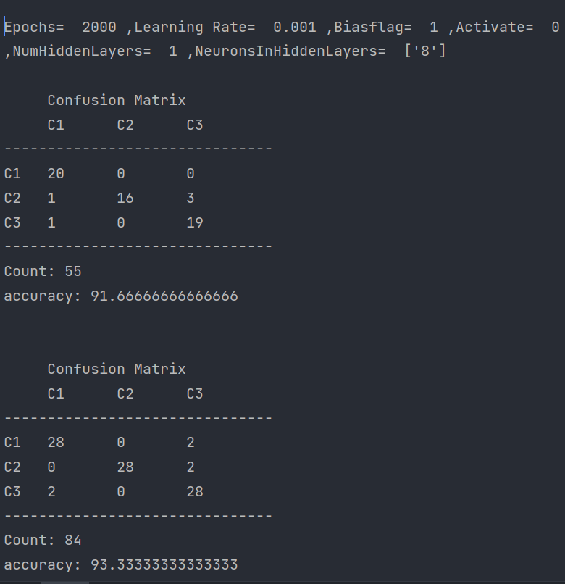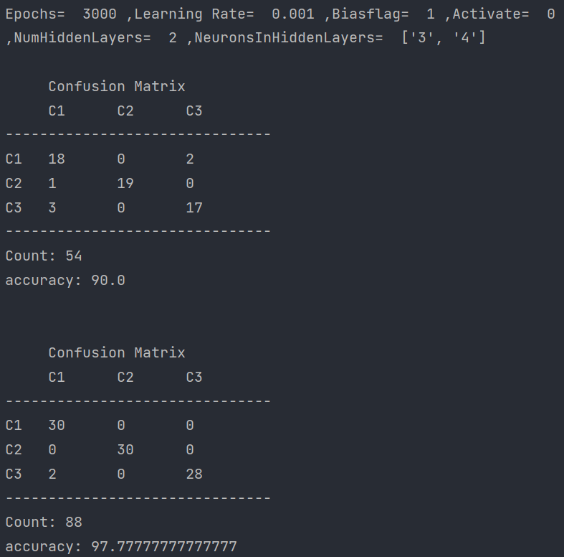

2

1

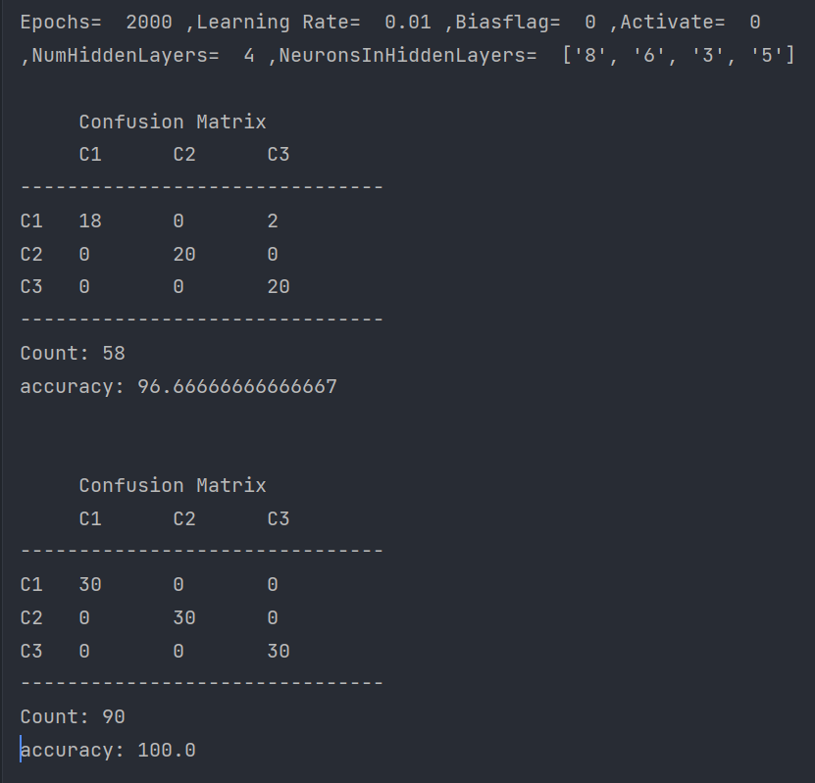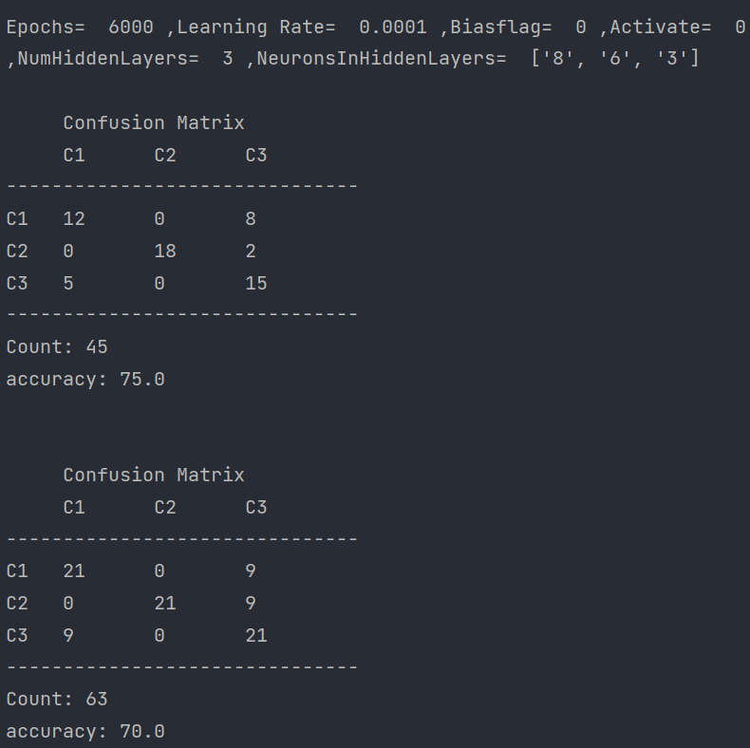

4

3

**GUI:**

We create GUI Using tkinter Library

GUI includes Number of Hidden Layers and Number of Neurons in each hidden layer and Activation Function and Learning Rate and Epochs and Bias as inputs and Test Accuracy and Train Accuracy and Confusion Matrix as output.

